POINTS-US-OK-Calf Creek-Deep Basal Notch-White OK Frisco Chert-Novaculite-Early Archaic

***Calf Creek  
Cluster: Thebes Cluster***

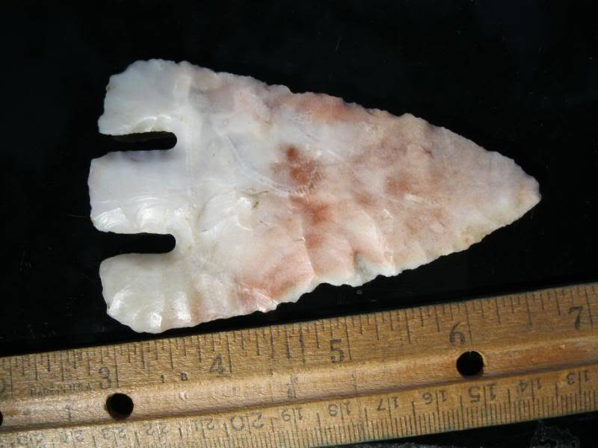

The Calf Creek point was named for the Calf Creek Cave site in Arkansas. These Early Archaic points are usually made of fine material, and the deep basal notching is diagnostic of the type. Southern variations of this same notching style in Texas are called Andice and Bell points

e:                        5,400 - 4,500 B.P.   
Cultural Period:        Middle Archaic  
Glacial Period:          Middle Holocene  
Culture:

***Similar Points:***[Andice,](http://www.projectilepoints.net/Points/Andice.html) [Bell,](http://www.projectilepoints.net/Points/Bell.html) [Castroville](http://www.projectilepoints.net/Points/Castroville.html), [Eva](http://www.projectilepoints.net/Points/Eva.html), [Mehlville](http://www.projectilepoints.net/Points/Mehlville.html), [Ocala](http://www.projectilepoints.net/Points/Ocala.html)

***Age Details:***These points were thought to represent an Early Archaic association with dates of 10,000 to 8,000 B.P.  However, recent radio-carbon dates have placed these points as having an Middle Archaic association.  The Kubik Site in Missouri had a date of  5,400 rcybp to 4,600 rcybp (Ray and Lopinot, 2003)

***Description of Physical Characteristics and Flaking Pattern:***

This is a medium to large (1.5 to 4.75 inches with 2 inches being average) triangular basal notch point with a thin flattened to elliptical cross section.  Finer material tend to be thinner while poorer materials are thicker.  The blade may vary from excurvate to straight.  In examples that are heavily re-sharpened the blade may take on a pentagonal appearance.  The blade may be serrated.  Long narrow notches enter the base forming a shoulder that has long drooping barbs that most commonly extend to the base of the point.  The barbs may be square or rounded. The stem may vary from straight to slightly expanding.  The base range from straight to slightly convex.  The base and stem are have smoothing / grinding present.  This point is made using roughly formed percussion flaking and finished with fine pressure flaking often resulting in fine serrations.  This point has a random flaking pattern.

***Size Measurements:***Total Length - 54 to 110 mm (average 55 to 60 mm), Stem Length - 10 to 20 mm,  Width - 35 to 55 mm (average 45 mm),  Stem Width - 20 to 30 mm.

***Distribution Comments:***

These points are most frequently found in Arkansas, eastern Oklahoma, eastern Kansas, and Missouri.  This point may be found in frequently in southern Indiana and southern Illinois.

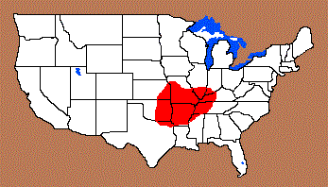

***Commonly Utilized Material:***Burlington, Frisco, Florence A, and Keokuk Osagean cherts are commonly heat treated and Reeds Spring chert lacks the heat treatment

***Additional Comments:***Extreme re-sharpened examples may lack the long barbs.  
  
This point is similar to the Lost Lake point except that this point has long drooping barbs while the Lost Lake barbs end in a  point (Justice, 1987).

***Outline is Representative of Common Size and Shape:***

***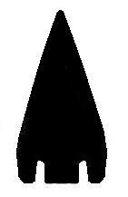***

***Name Details:*Named By:** Donald R. Dickson  
**Named For**:  Type Site  
**Date Identified**:  1968  
**Type Site**:  Calf Creek Cave, Searcy County, Arkansas

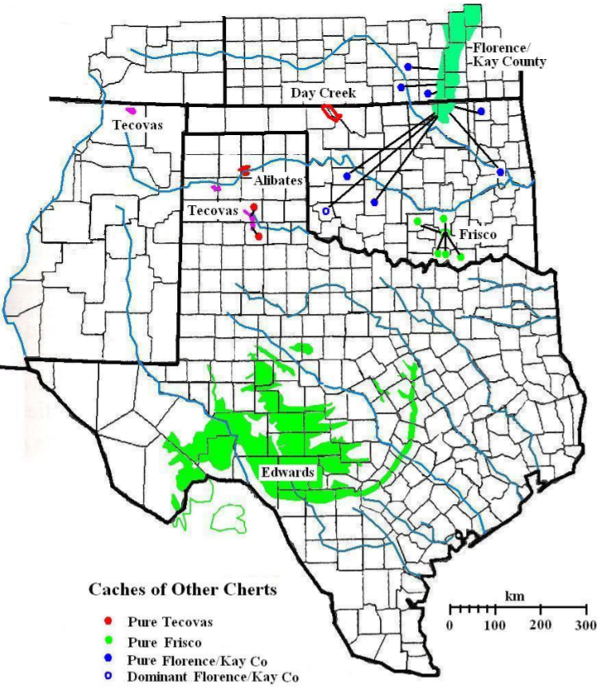

Andice points are more frequently made from triangular preforms, Calf Creek more ovoid. Andice, for the most part, get larger than Calf Creek but that could be largely due to the materials that were available. Stems on Andice are usually parallel to contracting while Calves are from parallel to expanding (both can be recurved). Some things that you will see on Calves that you typically won't on Andice are: lobed or auriculate bases, serrations, heavy torque resharpening. These are all hold-over traits from the Cossattot River points.   
  
  
  
I cast all of the "original" Calf Creek points that Don Dickson excavated out of Calf Creek Cave. There was a lot of variance in them but they did all have the typical CC traits. Materials ranged from Pitkin, Novaculite and Pierson. One thing I have noticed about the people is that they liked to use colorful materials. For instance, Reed Springs is just as common (if not more so), but they utilized Keokuk and other materials more. When they did use Reeds, it's usually the higher-grade lustrous stuff. In central Oklahoma Frisco is the chert of choice and up north heated Kay Co. seems to be preferred.

[SIGPIC][/SIGPIC] [http://www.arrowheads1.com](http://www.arrowheadology.com/forums/redirect-to/?redirect=http%3A%2F%2Fwww.arrowheads1.com" \t "_blank)

Here are examples from John Richardsons collection, all Oklahoma pieces.  
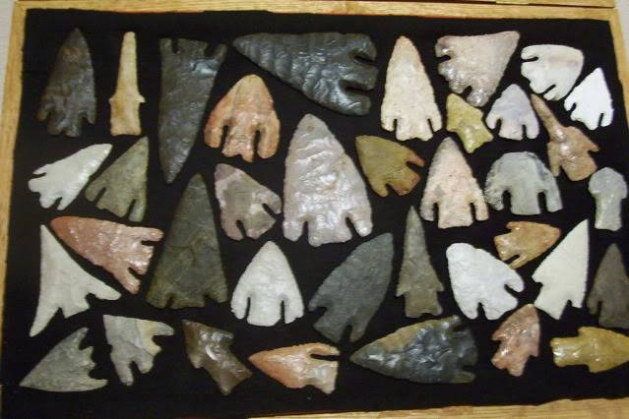  
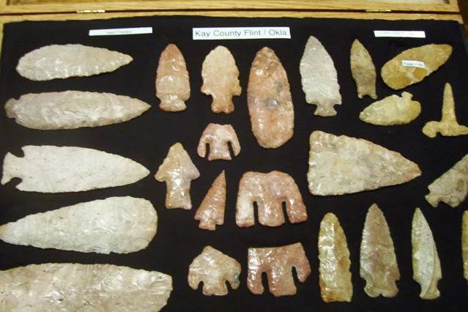  
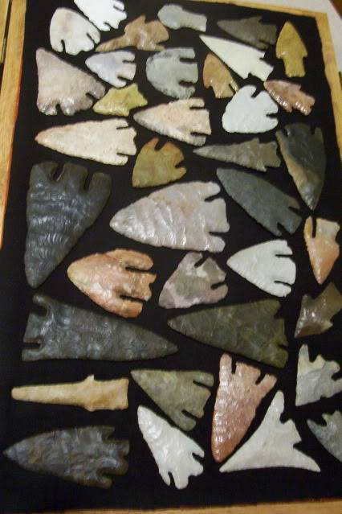  
That big black honker is the largest one I've ever seen from Ok. and was a river find.

[**[Reply With Quote](http://www.arrowheadology.com/forums/newreply.php?do=newreply&p=93704)Reply With Quote**](http://www.arrowheadology.com/forums/newreply.php?do=newreply&p=93704)

This Calf Creek Arrowhead was found in Muskogee, OK

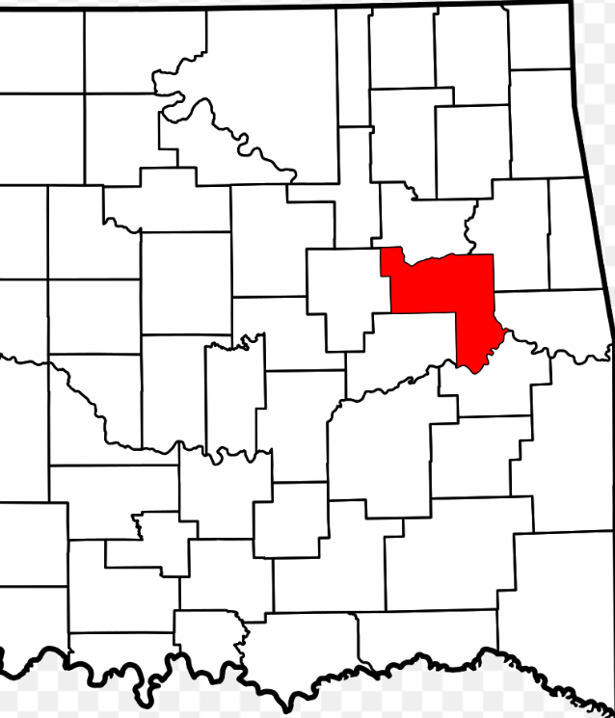 It is absolutely. G10- Example. There is no ancient or modern damage. The morphology is perfect with the expanding base, deep notches, and straight ears which reach the base.

It is large for calf Creek measuring 3-5/16" by 1-7/8".

The craftsmanship is excellent. I have found many calf Creek points in Oklahoma and almost all have been heat treated Kay County Chert, except for one that was from McIntosh County and was from St. John's